# Big Data Hadoop Training

Session 8 Assignment 2 Solution:

Task

**Create a sample dataset and implement the below Pig commands on the same dataset.**

**Sample dataset (used) –**

/My_Downloads/Assignments_BDH/BDDS8A2/student_details.txt

/My_Downloads/Assignments_BDH/BDDS8A2/duplicate_student_details.txt

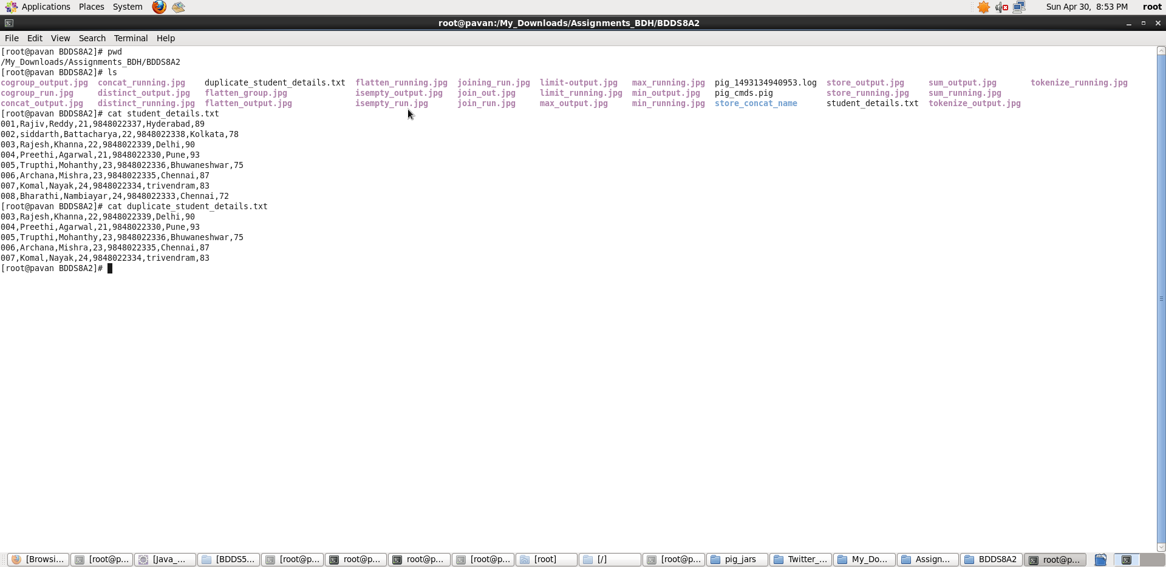

**Pig Commands:**

1. Concat

**Pig Latin Script**:

student_details = LOAD './student_details.txt' USING PigStorage(',') as (Id:int, firstName:chararray, lastName:chararray, age:int, phone_no:chararray, gpa:int);

concat_output = FOREACH student_details GENERATE CONCAT (firstName,'*',lastName);

dump concat_output;

**Explanation:**

* Loaded data from student_details.txt into “student_details” relation. Here ‘,’ is the delimiter and schema is provided accordingly
* Then, for all records I have generated a new relation which contains concatenated result of the firstName and lastName using CONCAT function. Here ‘*’ is kept in between the firstName and lastName and all the three expressions are concatenated.
* Outputting the concat_output

**Screenshots**

Running **Pig Latin Script in Local Mode** inside /My_Downloads/Assignments_BDH/BDDS8A2/ directory

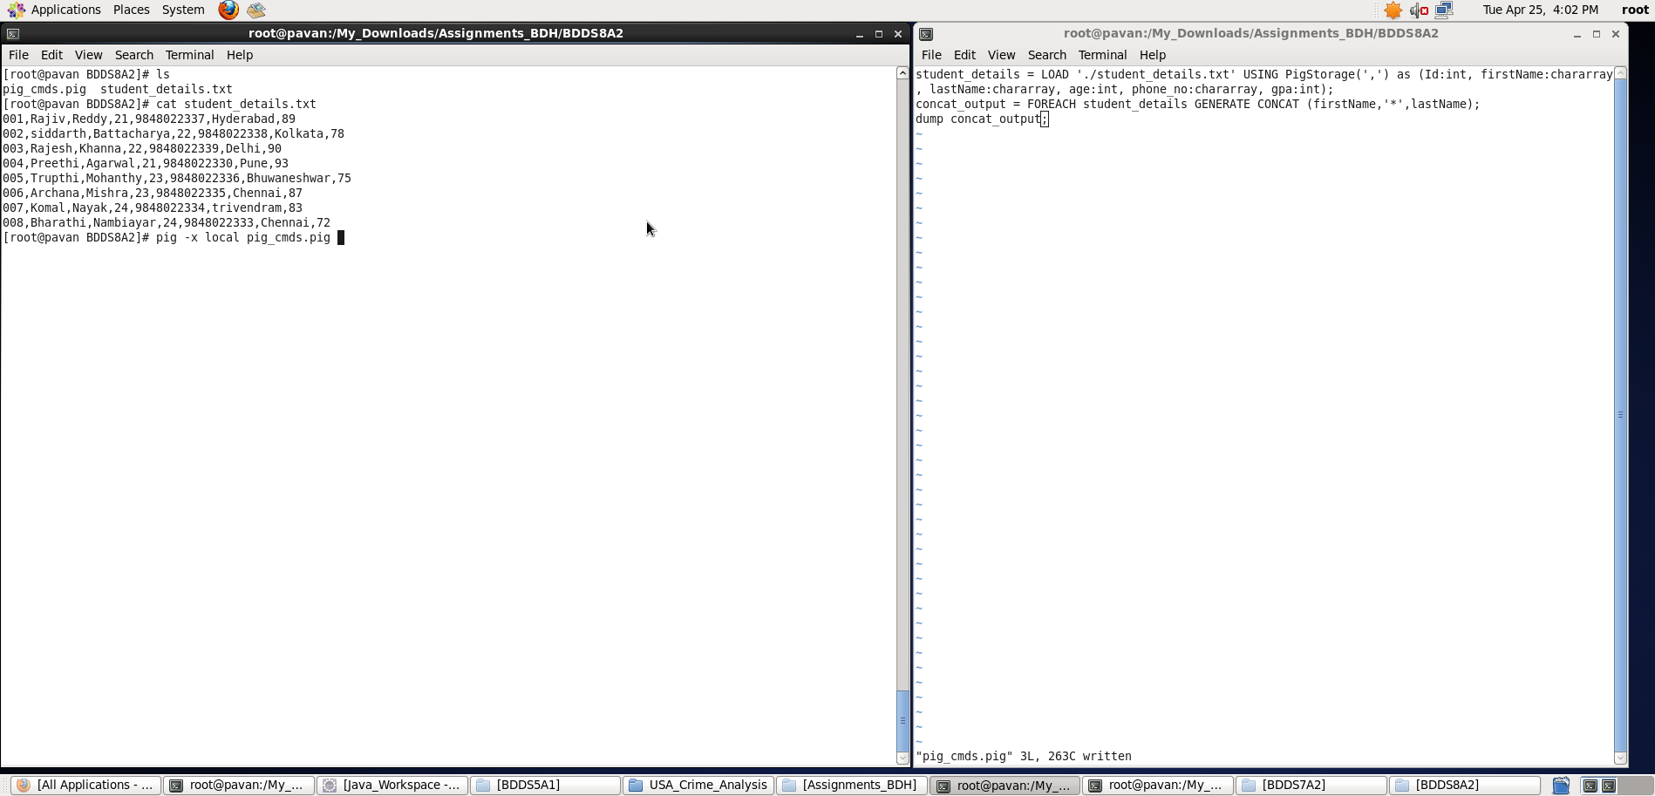

Output displayed: **<concat_output>**

**Note : We can store the output if required in a file using “store” command.**

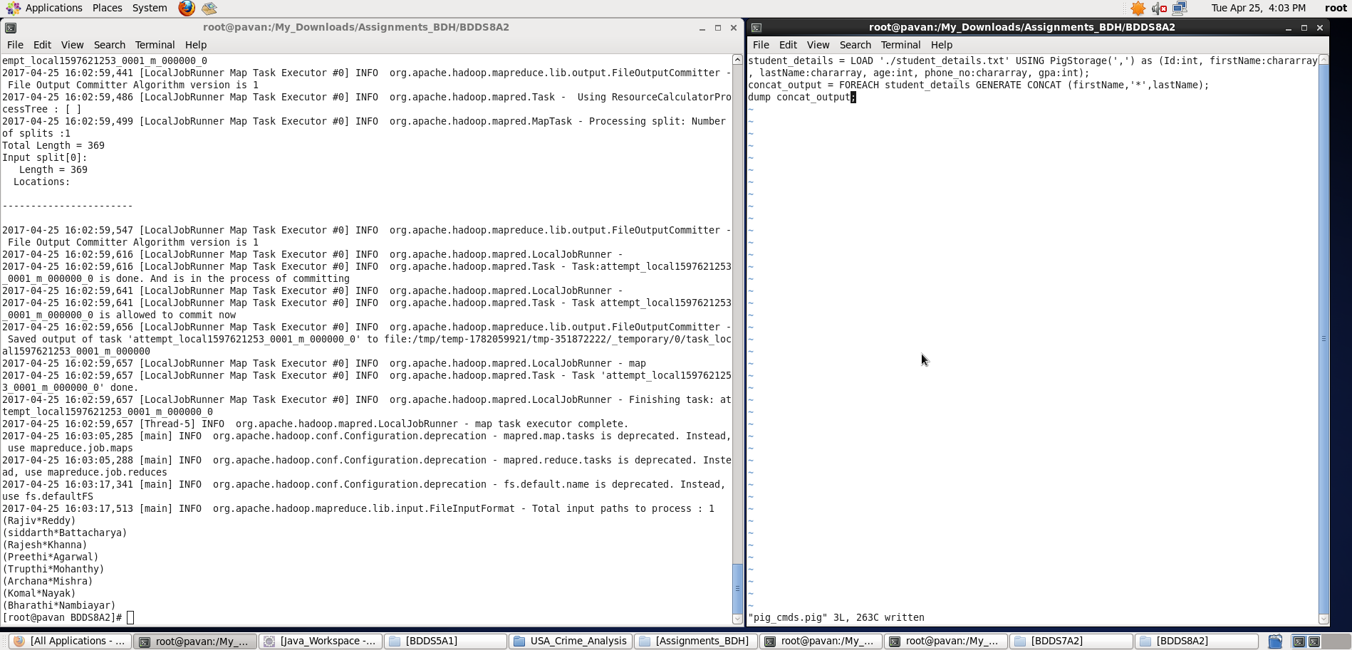

1. Tokenize

**Pig Latin Script**:

student_details = LOAD './student_details.txt' USING PigStorage(',') as (Id:int, firstName:chararray, lastName:chararray, age:int, phone_no:chararray, gpa:int);

concat_output = FOREACH student_details GENERATE CONCAT (firstName,'*',lastName);

tokenize_output = FOREACH concat_output GENERATE TOKENIZE ($0);

dump tokenize_output;

**Explanation:**

* Loaded data from student_details.txt into “student_details” relation. Here ‘,’ is the delimiter and schema is provided accordingly
* Then, for all records I have generated a new relation which contains concatenated result of the firstName and lastName using CONCAT function. Here ‘*’ is kept in between the firstName and lastName and all the three expressions are concatenated.
* Now, using TOKENIZE function , split the concat_output (which contains a group of words) in a single tuple and returns a bag which contains the output of the split operation.
* Outputting the tokenize_output

**Screenshots**

Running **Pig Latin Script in Local Mode** inside /My_Downloads/Assignments_BDH/BDDS8A2/ directory

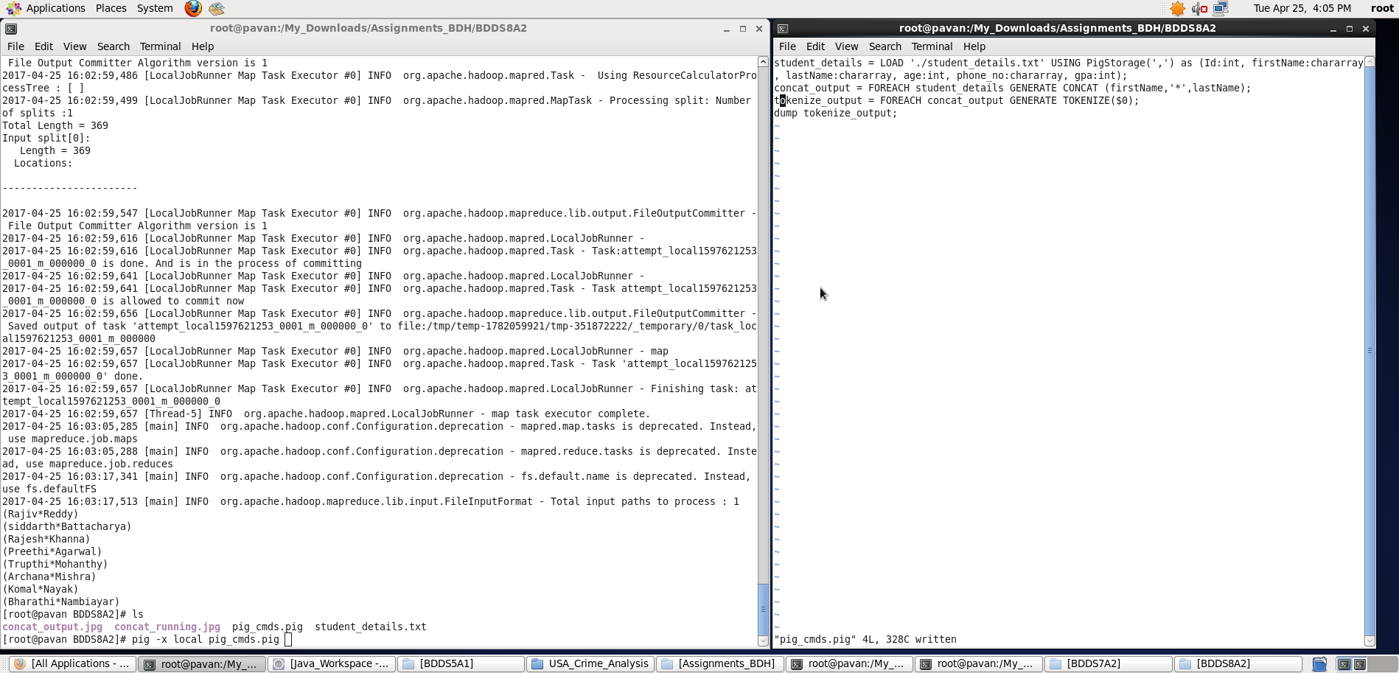

Output displayed: **<tokenize_output>**

**Note : We can store the output if required in a file using “store” command.**

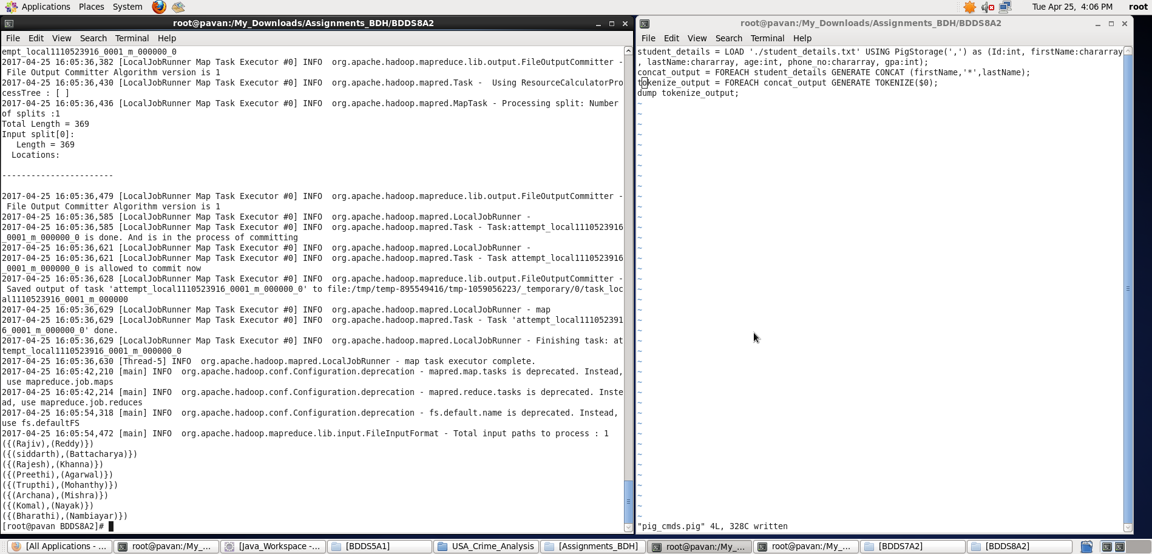

1. Sum

**Pig Latin Script**:

student_details = LOAD './student_details.txt' USING PigStorage(',') as (Id:int, firstName:chararray, lastName:chararray, age:int, phone_no:chararray, gpa:int);

grpallstudents = GROUP student_details all;

age_total = FOREACH grpallstudents GENERATE SUM(student_details.age);

dump age_total;

**Explanation:**

* Loaded data from student_details.txt into “student_details” relation. Here ‘,’ is the delimiter and schema is provided accordingly
* Then, grouping all the records into a single relation.
* Finding the sum of all ages of all students using SUM function.
* Outputting the age_total relation.

**Screenshots**

Running **Pig Latin Script in Local Mode** inside /My_Downloads/Assignments_BDH/BDDS8A2/ directory

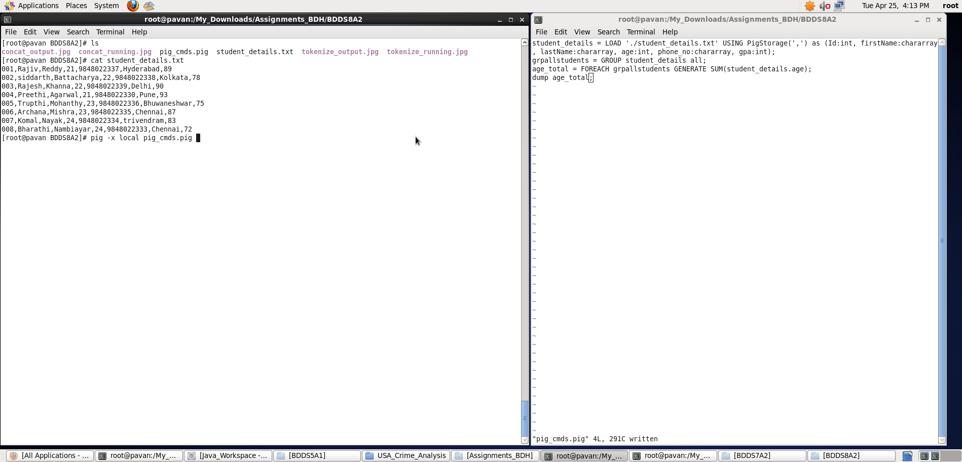

Output displayed: **<age_total>**

**Note : We can store the output if required in a file using “store” command**

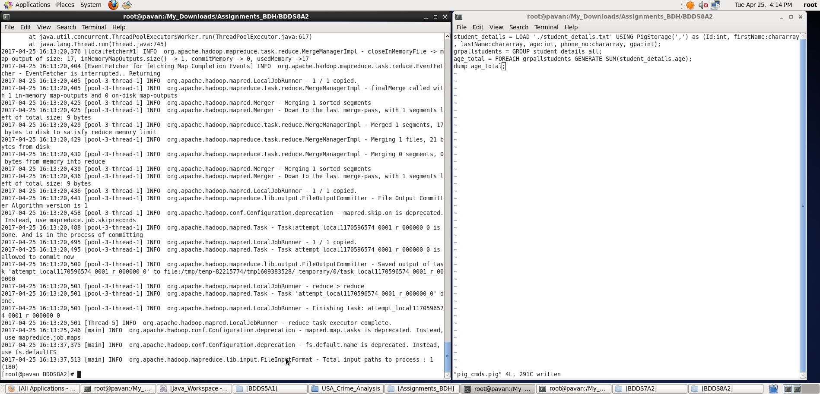

1. Min

**Pig Latin Script**:

student_details = LOAD './student_details.txt' USING PigStorage(',') as (Id:int, firstName:chararray, lastName:chararray, age:int, phone_no:chararray, gpa:int);

grpallstudents = GROUP student_details all;

age_min = FOREACH grpallstudents GENERATE MIN(student_details.age);

dump age_min;

**Explanation:**

* Loaded data from student_details.txt into “student_details” relation. Here ‘,’ is the delimiter and schema is provided accordingly
* Then, grouping all the records into a single relation.
* Finding the minimum of all ages of all students using MIN function.
* Outputting the age_min relation

**Screenshots**

Running **Pig Latin Script in Local Mode** inside /My_Downloads/Assignments_BDH/BDDS8A2/ directory

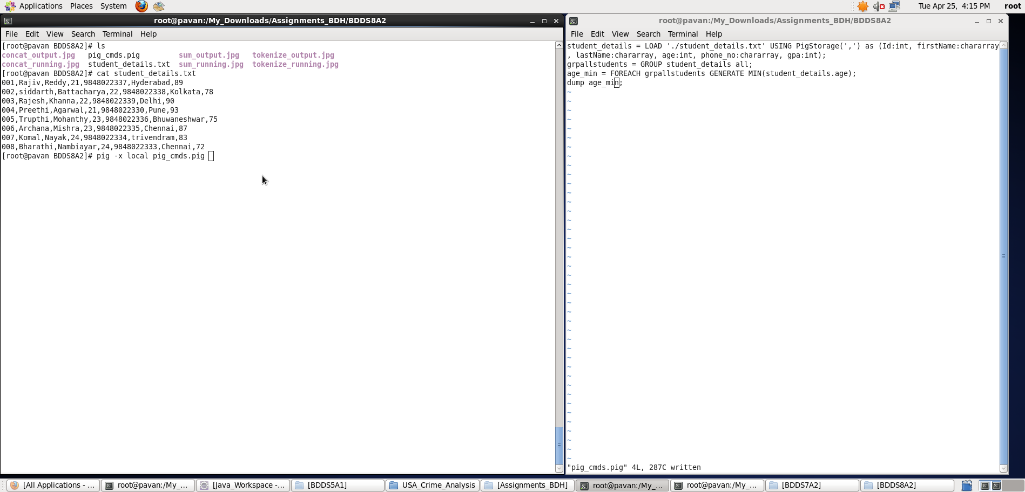

Output displayed: **<age_min>**

**Note : We can store the output if required in a file using “store” command**

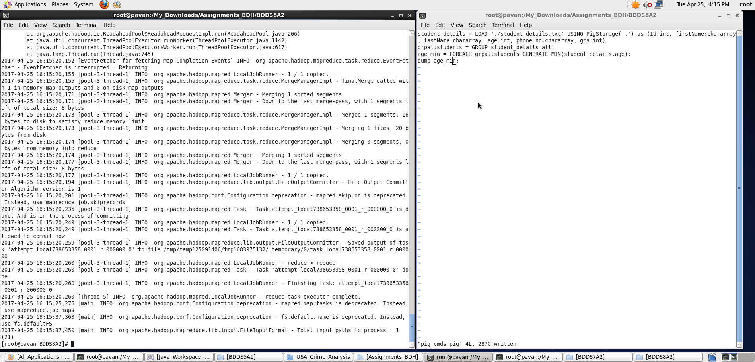

1. Max

**Pig Latin Script**:

student_details = LOAD './student_details.txt' USING PigStorage(',') as (Id:int, firstName:chararray, lastName:chararray, age:int, phone_no:chararray, gpa:int);

grpallstudents = GROUP student_details all;

age_max = FOREACH grpallstudents GENERATE MAX(student_details.age);

dump age_max;

**Explanation:**

* Loaded data from student_details.txt into “student_details” relation. Here ‘,’ is the delimiter and schema is provided accordingly
* Then, grouping all the records into a single relation.
* Finding the maximum of all ages of all students using MAX function.
* Outputting the age_max relation

**Screenshots**

Running **Pig Latin Script in Local Mode** inside /My_Downloads/Assignments_BDH/BDDS8A2/ directory

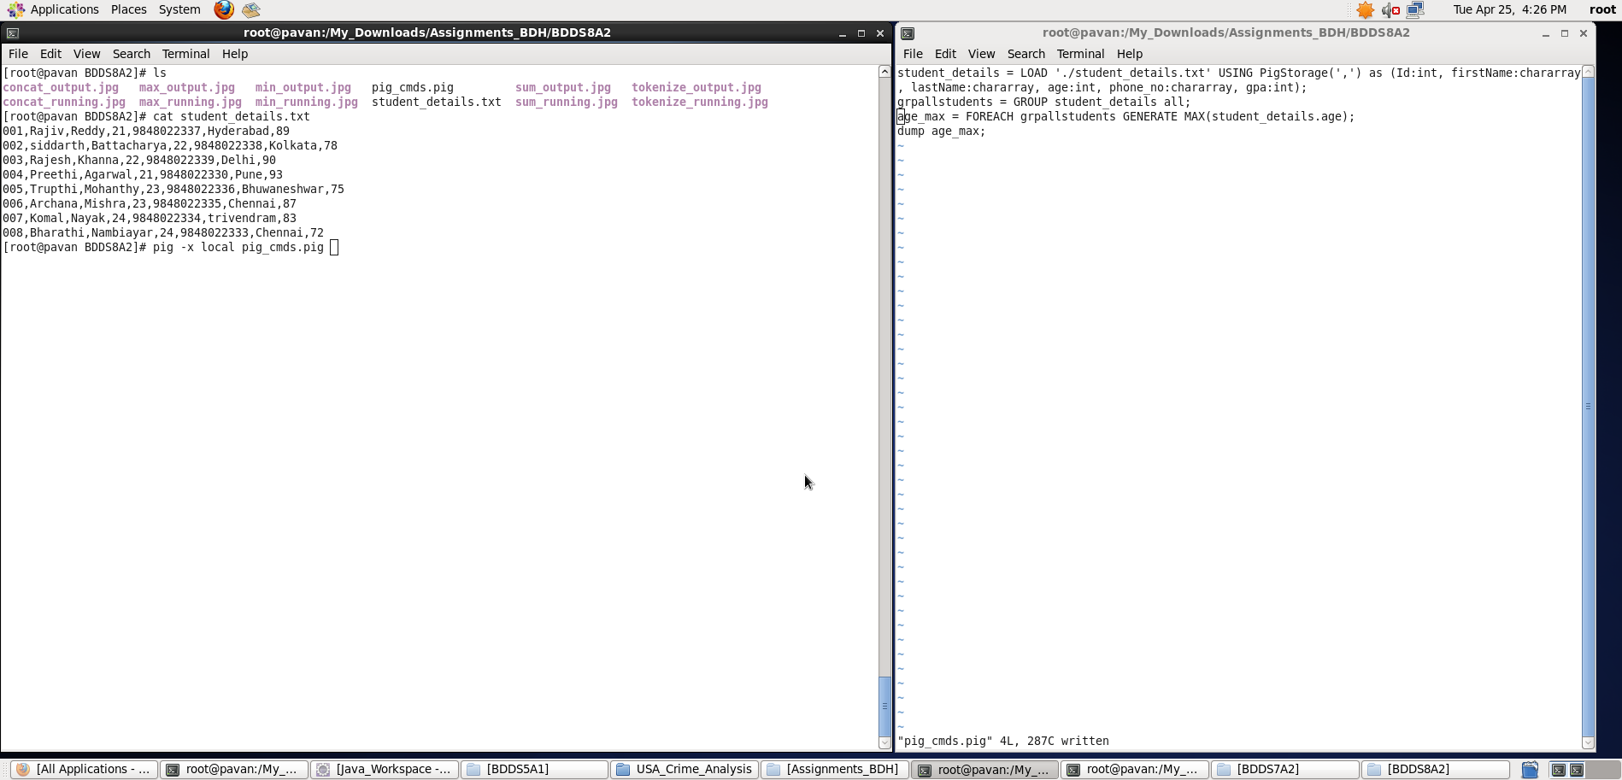

Output displayed: **<age_max>**

**Note : We can store the output if required in a file using “store” command**

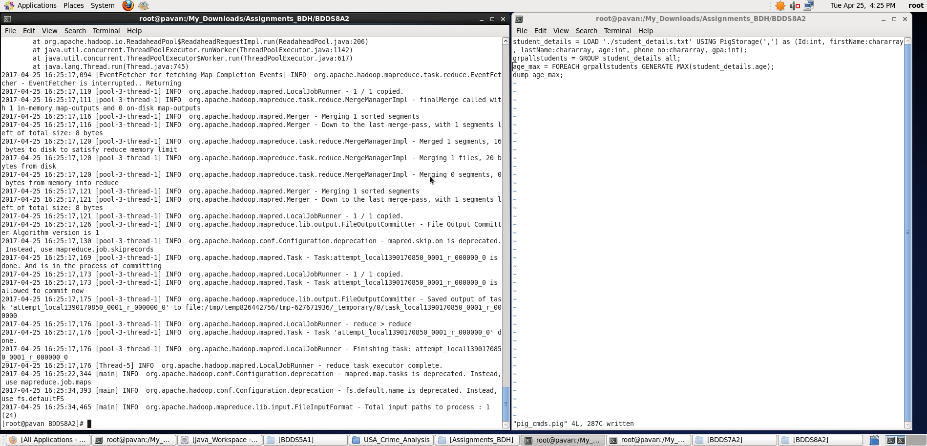

1. Limit

**Pig Latin Script**:

student_details = LOAD './student_details.txt' USING PigStorage(',') as (Id:int, firstName:chararray, lastName:chararray, age:int, phone_no:chararray, gpa:int);

list_first_3_std_details = LIMIT student_details 3;

dump list_first_3_std_details;

**Explanation:**

* Loaded data from student_details.txt into “student_details” relation. Here ‘,’ is the delimiter and schema is provided accordingly
* Then, storing the first n records say, n=3 here, from the student_details relation into list_first_3_std_details using LIMIT function.
* Outputting the list_first_3_std_details.

**Screenshots**

Running **Pig Latin Script in Local Mode** inside /My_Downloads/Assignments_BDH/BDDS8A2/ directory

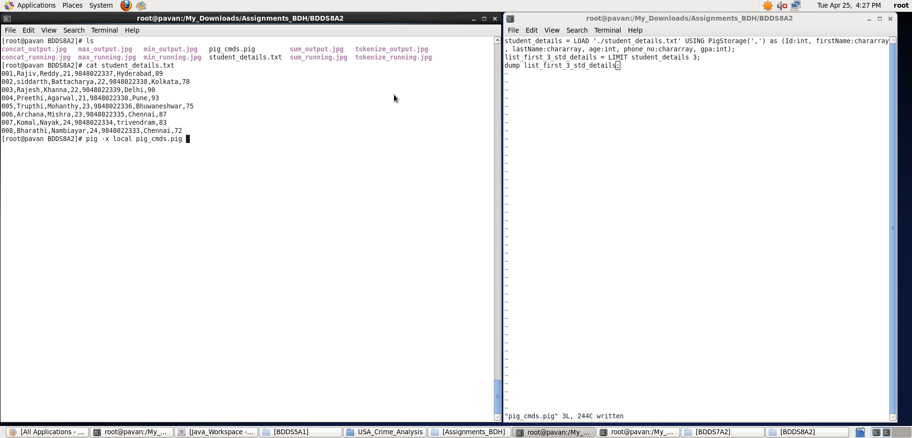

Output displayed: **<** **list_first_3_std_details>**

**Note : We can store the output if required in a file using “store” command**

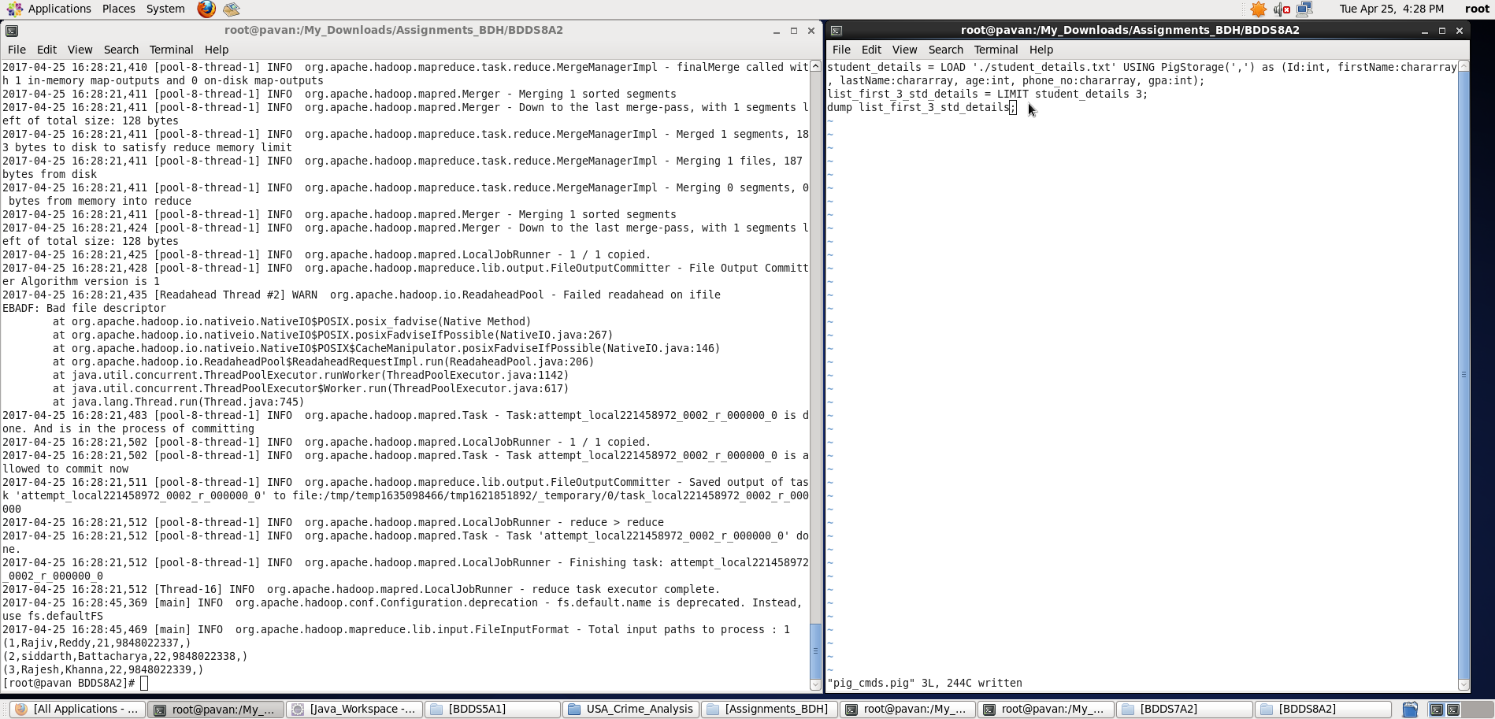

1. Store

**Pig Latin Script**:

student_details = LOAD './student_details.txt' USING PigStorage(',') as (Id:int, firstName:chararray, lastName:chararray, age:int, phone_no:chararray, gpa:int);

concat_name = FOREACH student_details GENERATE CONCAT (firstName,'_',lastName);

STORE concat_name INTO ‘./store_concat_name’;

**Explanation:**

* Loaded data from student_details.txt into “student_details” relation. Here ‘,’ is the delimiter and schema is provided accordingly
* Then, for all records I have generated a new relation which contains concatenated result of the firstName and lastName using CONCAT function. Here ‘_’ is kept in between the firstName and lastName and all the three expressions are concatenated.
* Instead of displaying concat_name relation using DUMP command, we can store the result into a specified directory using STORE command.

**Screenshots**

Running **Pig Latin Script in Local Mode** inside /My_Downloads/Assignments_BDH/BDDS8A2/ directory

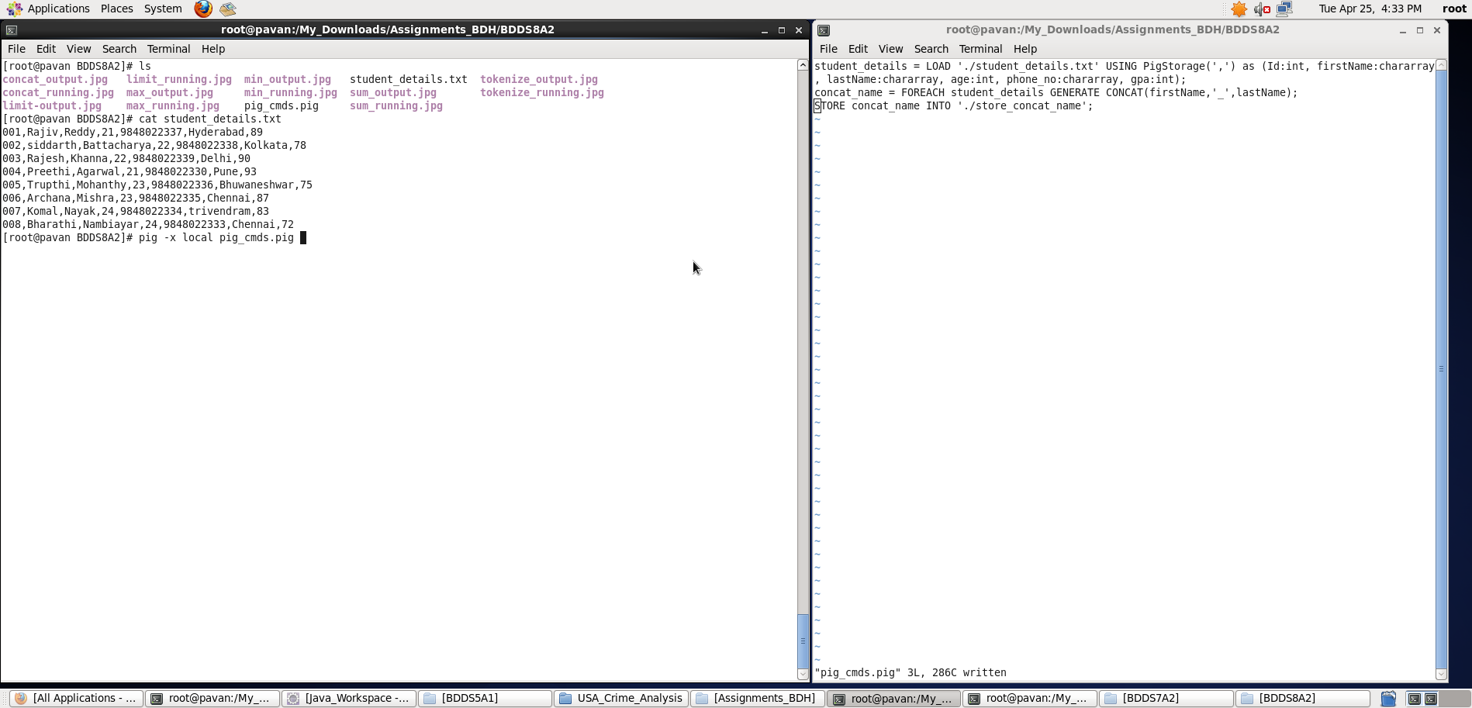

Once, the result got stored, we can view the result as follows using ‘cat’ command.

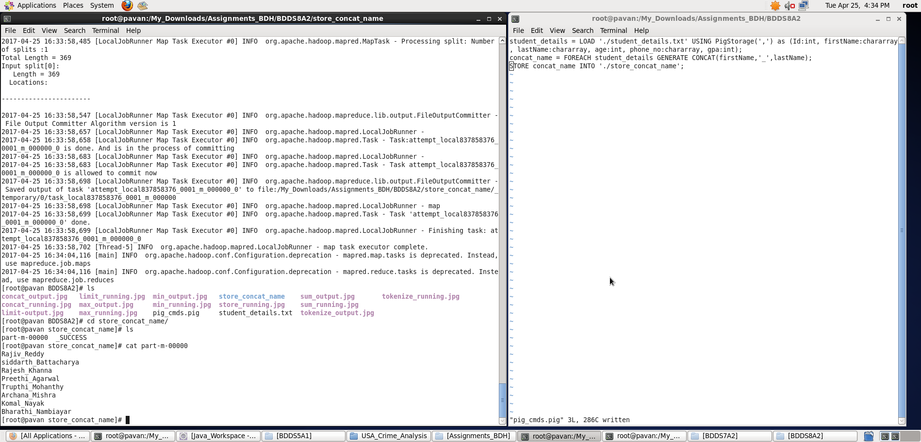

**Output stored <concat_name> inside ./store_concat_name/part-m-00000 file.**

1. Distinct

**Pig Latin Script**:

student_details = LOAD './student_details.txt' USING PigStorage(',') as (Id:int, firstName:chararray, lastName:chararray, age:int, phone_no:chararray, gpa:int);

distinct_student_details = DISTINCT student_details;

dump distinct_student_details;

**Explanation:**

* Loaded data from student_details.txt into “student_details” relation. Here ‘,’ is the delimiter and schema is provided accordingly
* **Note: I have copied some duplicate records into the student_details.txt file (as shown in below screenshot) using cat command.**
* Now, with the help of DISTINCT function, I have eliminated the duplicate records from the student_details relation.
* Outputting distinct_student_details.

**Screenshots**

Running **Pig Latin Script in Local Mode** inside /My_Downloads/Assignments_BDH/BDDS8A2/ directory

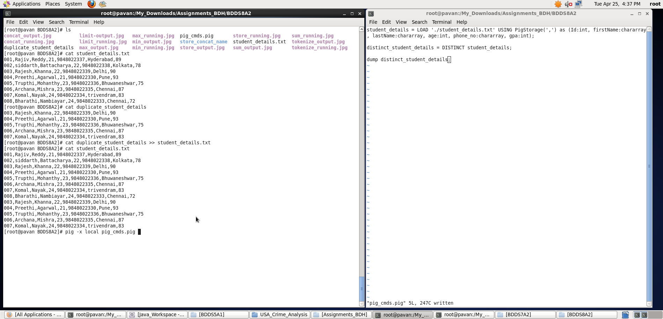

Output displayed: **<distinct_student_details>**

**Note : We can store the output if required in a file using “store” command**

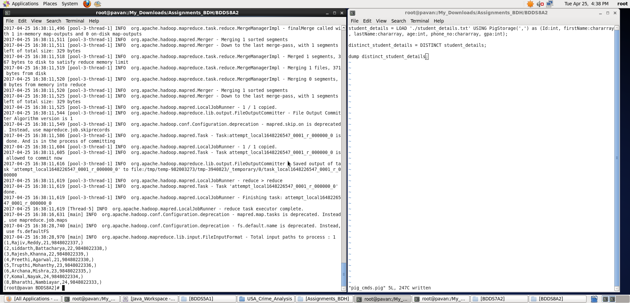

1. Flatten

**Pig Latin Script**:

student_details = LOAD './student_details.txt' USING PigStorage(',') as (Id:int, firstName:chararray, lastName:chararray, age:int, phone_no:chararray, gpa:int);

grpbyage = GROUP student_details by age;

flatten_output = foreach grpbyage generate group, flatten(student_details);

dump flatten_output;

**Explanation:**

* Loaded data from student_details.txt into “student_details” relation. Here ‘,’ is the delimiter and schema is provided accordingly
* Then, grouping the records based on age (key).
* We can see the grpbyage relation (output it using dump as shown below) as a tuple
* **The FLATTEN operator looks like a UDF syntactically, but it is actually an operator that changes the structure of tuples and bags in a way that a UDF cannot. Flatten un-nests tuples as well as bags.**
* Now, using flatten operator, I have un-nested the grpbyage tuple into individual records as shown below.

**Screenshots**

Running **Pig Latin Script in Local Mode** inside /My_Downloads/Assignments_BDH/BDDS8A2/ directory

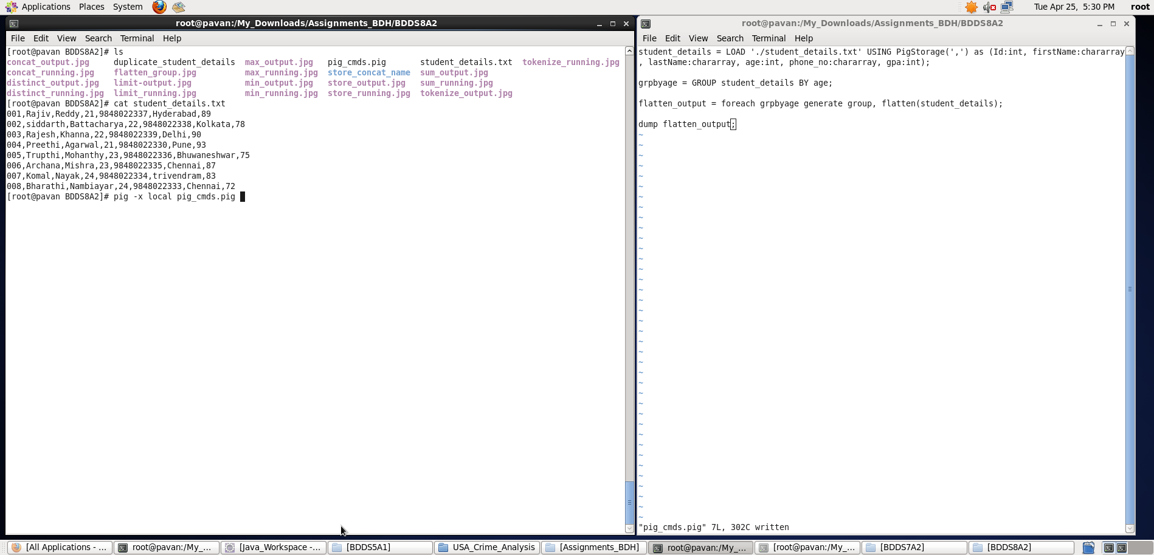

Output displayed: **<grpbyage>**

**Note : We can store the output if required in a file using “store” command**

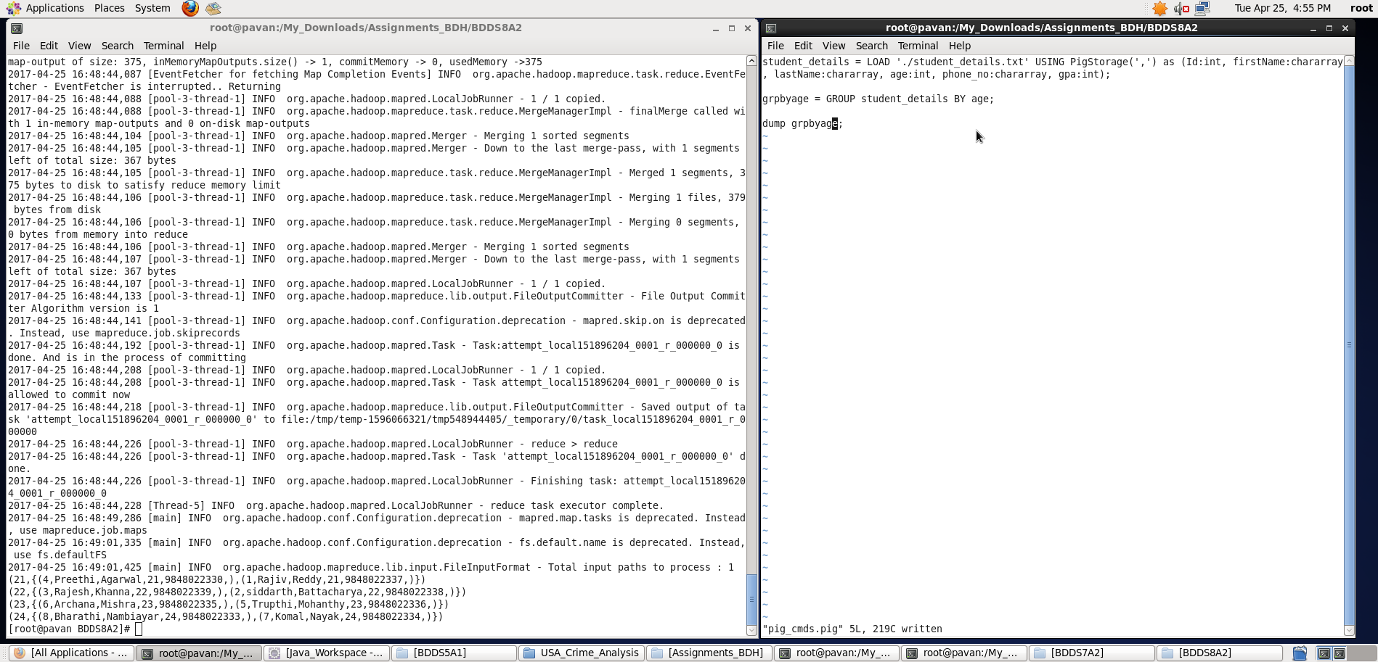

Output displayed: **<flatten_output>**

**Note : We can store the output if required in a file using “store” command**

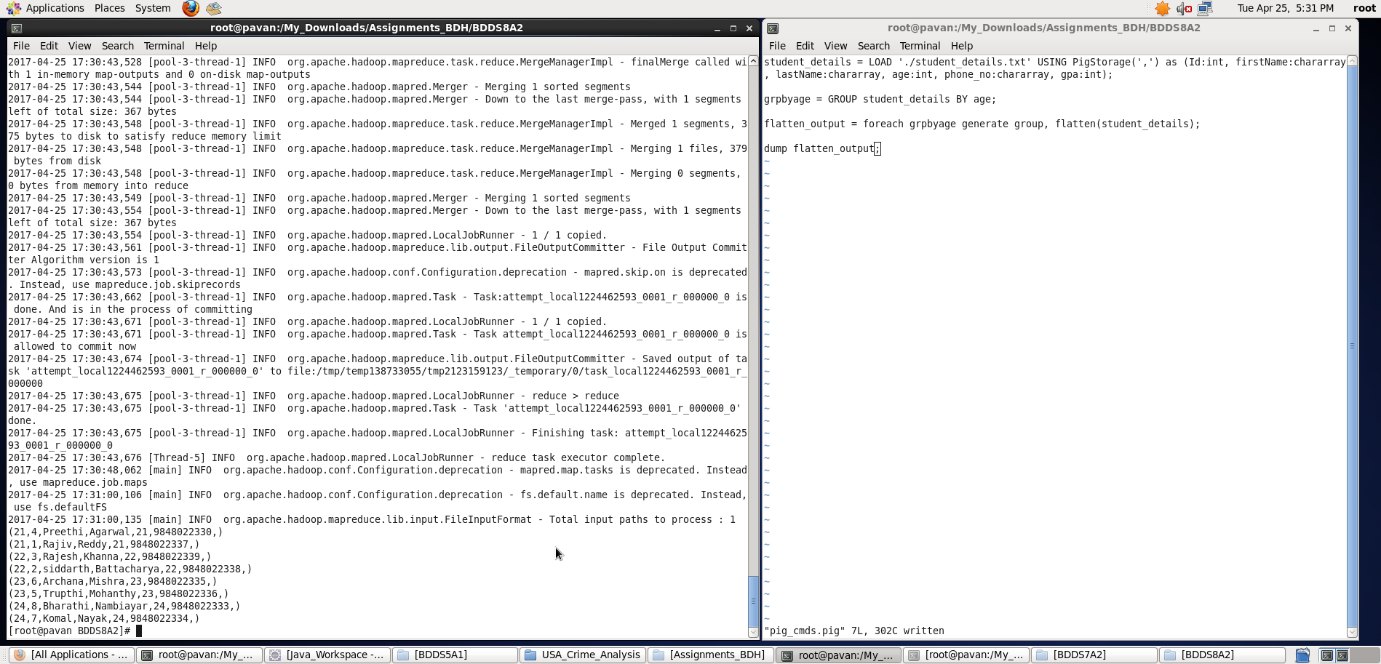

1. IsEmpty

**Pig Latin Script**:

student_details = LOAD './student_details.txt' USING PigStorage(',') as (Id:int, firstName:chararray, lastName:chararray, age:int, phone_no:chararray, gpa:int);

duplicate_details = LOAD './duplicate_student_details.txt' USING PigStorage(',') as (Id:int, firstName:chararray, lastName:chararray, age:int, phone_no:chararray, gpa:int);

cogroup_data = COGROUP student_details by Id, duplicate_details by Id;

isempty_data = filter cogroup_data by IsEmpty(duplicate_details);

dump isempty_data;

**Explanation:**

* Loaded data from student_details.txt into “student_details” relation. Here ‘,’ is the delimiter and schema is provided accordingly.
* Loaded data from duplicate_student_details.txt into “duplicate_details” relation. Here ‘,’ is the delimiter and schema is provided accordingly.
* Now, co-grouping both the relations based on common key – Id (here) into cogroup_data relation.
* **Note**: **There will be some empty fields in this cogroup_data (as shown in below screenshot) because all the Id’s in student_details wont have corresponding records in duplicate_details.**
* Therefore, filtering based on empty duplicate_details field in cogroup_data relation using IsEmpty function.
* **IsEmpty function returns True if that corresponding field is empty.**
* Outputting the isempty_data

**Screenshots**

Running **Pig Latin Script in Local Mode** inside /My_Downloads/Assignments_BDH/BDDS8A2/ directory

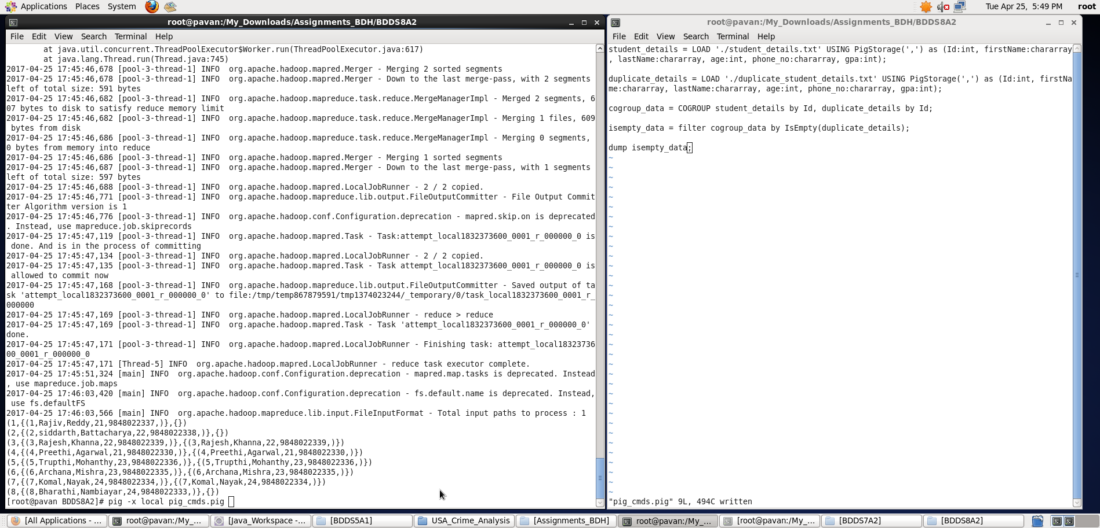

Output displayed: **<isempty_data>**

**Note : We can store the output if required in a file using “store” command**

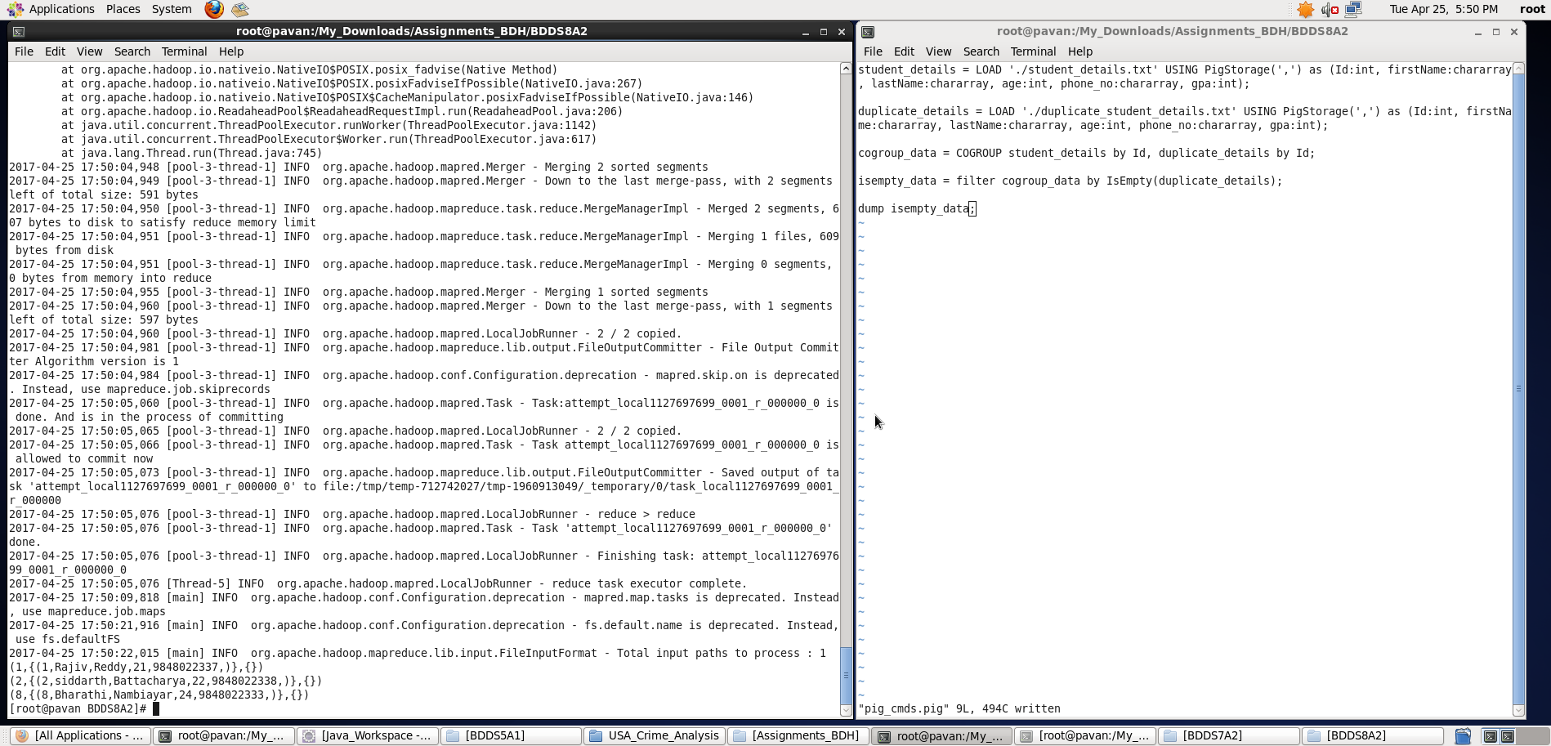

**Thus, I have created a sample dataset and implemented the stated Pig commands on the dataset.**